**APPLICATION CONTAINERIZATION**

**LAB EXPERIMENT 12**

**SUBMITTED BY:**

NITISH KUMAR SINGLA

500071913

R171218126

**SUBMITTED TO:**

HITESH KUMAR SHARMA SIR

**Working with Metadata, Log File using Docker**

In the background, there is an instance of Redis running with the name redis-server. Using the Docker client, we can access the standard out and standard error outputs using

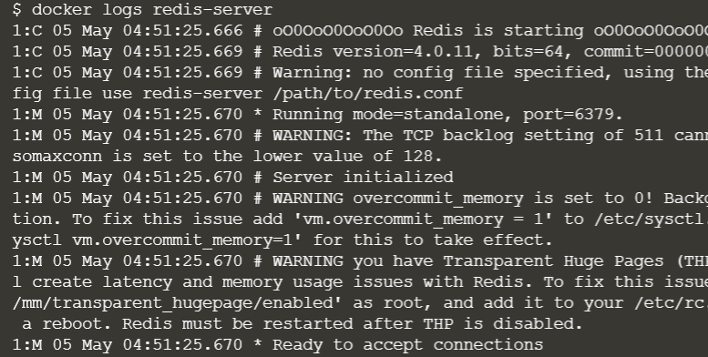

The command below will redirect the redis logs to syslog.



When the container is launched simply set the log-driver to none. No output will be logged.



The inspect command allows you to identify the logging configuration for a particular container. The command below will output the LogConfig section for each of the containers.

Server created in step 1



Server created in step 2



Server created in this step

